NAME : Revanth Reddy A

ROLL NO : 422113

SEC : A

Q 1) Wíite shell scíipt foí commands:

UNIX ASSIGNMENT

moíe,nl,nice,passwd,pí,ílogin,ícp,ísh,talk,telnet,tput,tty,uname,wc,who,wíite

Ans :

#! /bin/bash

# more command

cat sample.txt

echo " "

echo " more -d sample.txt"

more -d sample.txt

echo " "

echo "more -f sample.txt"

more -f sample.txt

# more -p sample.txt

# more -c sample.txt

echo " "

echo "more -u sample.txt"

more -u sample.txt

echo " "

echo "more -s sample.txt"

more -s sample.txt

echo " "

echo "more +5 sample.txt"

more +5 sample.txt

echo " "

echo "mmore +/Lorem sample.txt"

more +/Lorem sample.txt

echo " "

# nl command

nl file1.txt

echo ""

nl -b a file1.txt

echo ""

nl -l 1 file1.txt

echo ""

nl -i3 file1.txt

echo ""

nl -v4 file1.txt

echo ""

nl -s "..." file1.txt

echo ""

nl -w2 file1.txt

nl -w4 file1.txt

nl -w6 file1.txt

echo ""

nl -n ln file1.txt

nl -n rn file1.txt

nl -n rz file1.txt

echo ""

#nice command

ps -el | grep terminal

echo ""

nice -10 gnome-terminal

echo ""

nice --10 gnome-terminal

echo ""

sudo renice -n 15 -p 2732

echo ""

#renice -n 10 -g 1

echo ""

#sudo renice -n 10 -u 1

echo ""

# passwd command

sudo passwd root

echo ""

passwd revanth422113

echo ""

#pr command

cat file1.txt

echo ""

pr -3 file1.txt

echo ""

pr -t file1.txt

echo ""

pr -d file1.txt

echo ""

pr -n file1.txt

echo ""

pr -h "header" file1.txt

echo ""

pr --version

echo ""

#rlogin command

rlogin -l revanth422113 Revanth422113

echo ""

rlogin -T terminal_type revanth422113

echo ""

#rcp command

rcp Revanth422113:file1.txt

echo ""

rcp -p Revanth422113:one/file1.txt

echo ""

#telnet command

telnet localhost

logout

echo ""

#tput command

tput init

echo ""

tput reset

echo ""

tput longname

echo ""

tput -V

echo ""

#tty command

tty

tty -s

tty --version

#uname command

echo ""

uname -a

echo ""

uname -s

echo ""

uname -n

echo ""

uname -r

echo ""

uname -v

echo ""

uname -m

echo ""

uname -p

echo ""

uname -i

echo ""

uname -o

#wc command

wc file1.txt

echo ""

wc file2.txt

echo ""

wc file1.txt file2.txt

echo ""

wc -l file1.txt

echo ""

wc -l file1.txt file2.txt

echo ""

wc -w file1.txt

echo ""

wc -w file1.txt file2.txt

echo ""

wc -c file1.txt

echo ""

wc -c file1.txt file2.txt

echo ""

wc -m file1.txt

echo ""

wc -m file1.txt file2.txt

echo ""

wc -L file1.txt

echo ""

wc -L file1.txt file2.txt

echo ""

#who command

who -a

echo ""

who -b

echo ""

who -d

echo ""

who -H

echo ""

who -l

echo ""

who -m

echo ""

who -p

echo ""

who -q

echo ""

who -r

echo ""

who -s

echo ""

who -t

echo ""

who -u

echo ""

#write command

write -V

OUTPUT :

UN

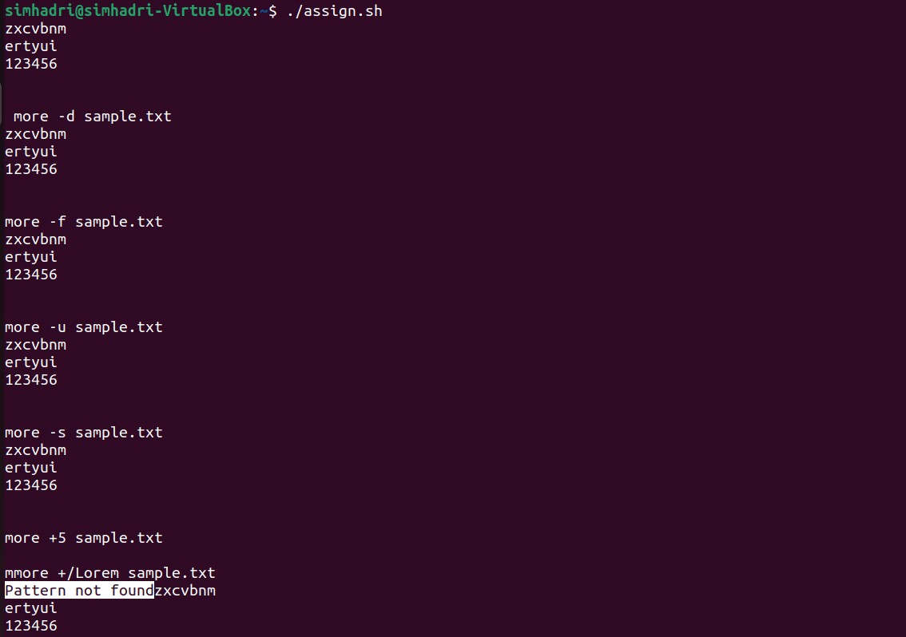

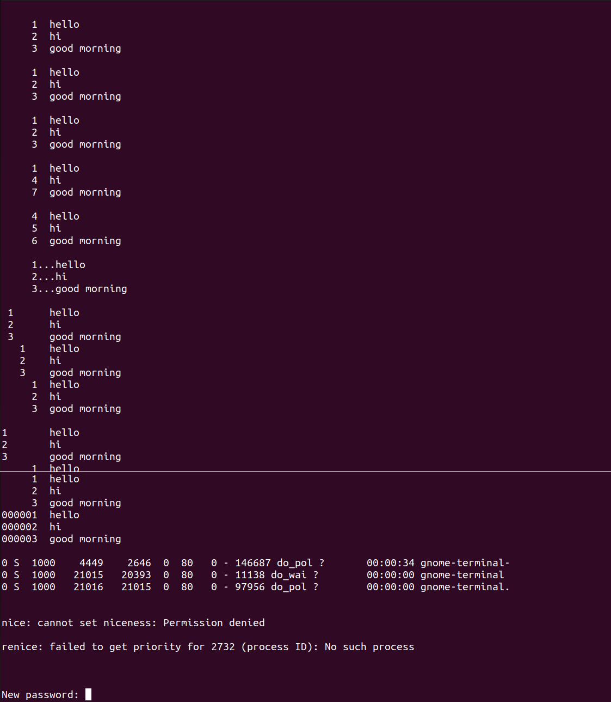

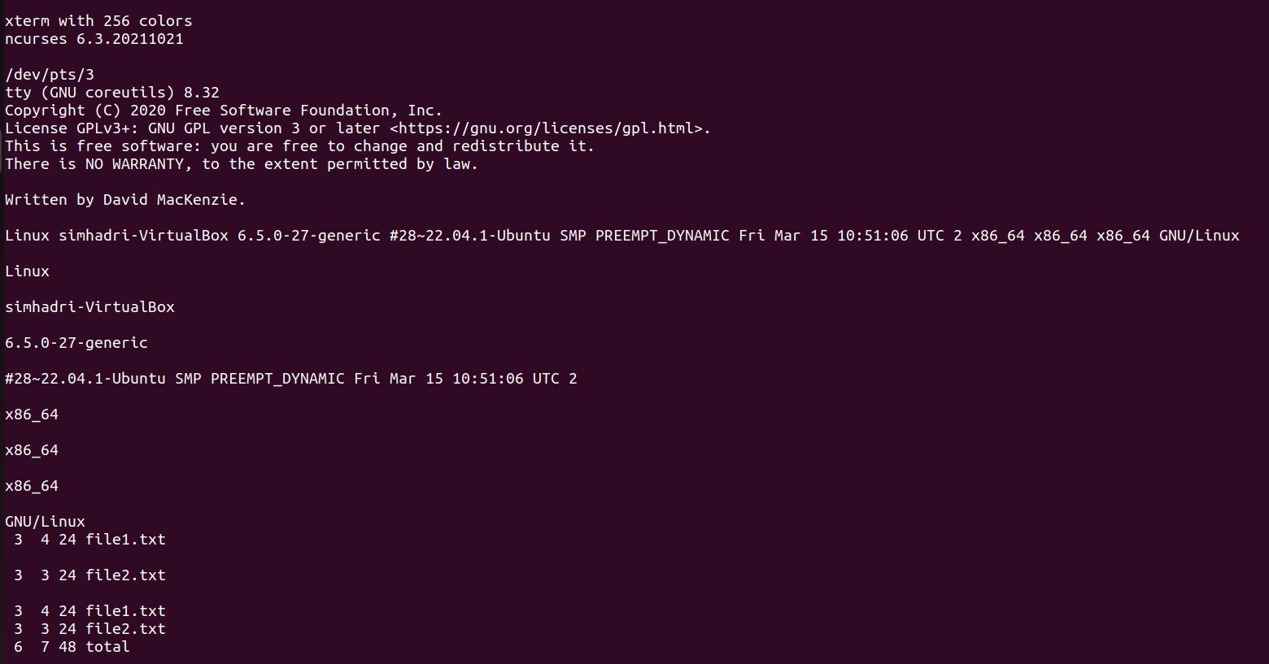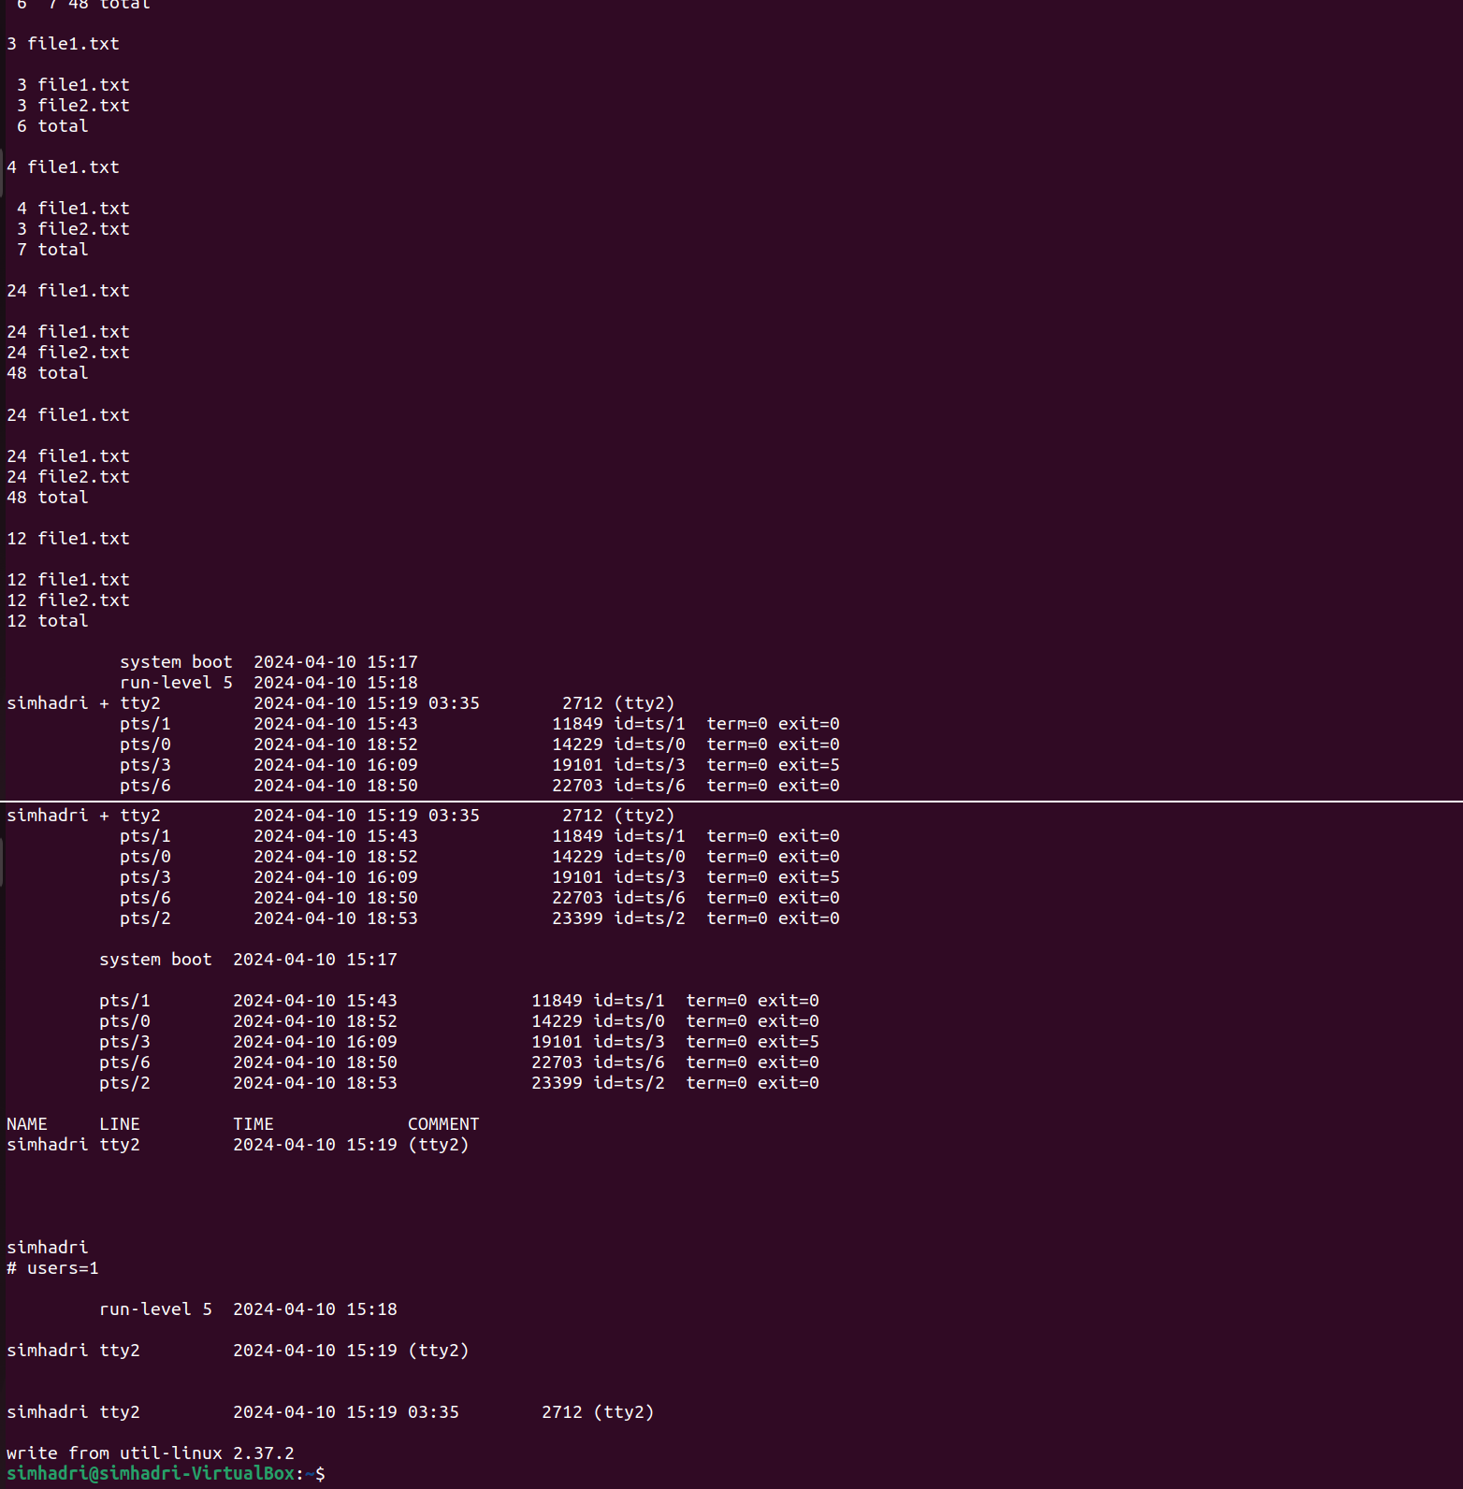

) Wíite a shell scíipt that list the memoíy usage and cpu usage of multiple machines. Ans :

mem.sh :

#!/bin/bash

# Define the list of remote machines

machines=[("stud](mailto:student@172.50.4.235)en[t@172.50.4.235](mailto:student@172.50.4.235)" ["student@](mailto:student@172.50.11.107)1[72.50.11.107](mailto:student@172.50.11.107)")

# Iterate over each machine and retrieve memory and CPU usage

for machine in "${machines[@]}"; do

echo "Memory and CPU usage for $machine:"

# SSH into the remote machine and retrieve memory usage

echo "Memory Usage:" ssh "$machine" 'free -m'

# SSH into the remote machine and retrieve CPU usage

echo "CPU Usage:"

ssh "$machine" 'mpstat' echo

done

OUTPUT :

